  JAHD240BT Waterproof  Heavy Duty Two Channel  Audio Amplifier | 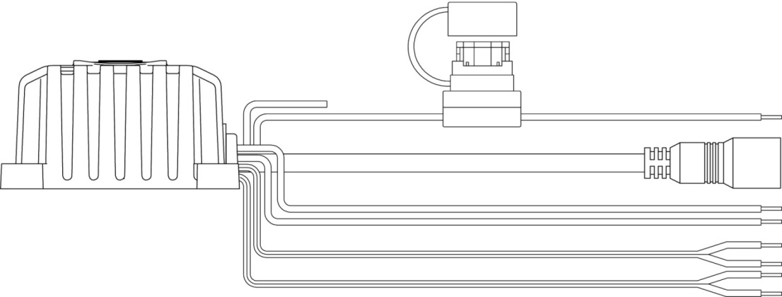  Yellow  Red  Black  Gray/Black  Gray  White/Black  White  Bluetooth Antenna  DO NOT CUT/CONNECT  10 A Fuse  Switch Cable  Switch Cable  Power/Pairing Switch
Features  - Bluetooth Audio (A2DP)  - 2 x 40 Watt Max Power Rating  - 2 x 20 Watt RMS  - 4 Ω – 8 Ω (ohm) Stable  - Frequency Response: 20 Hz – 20 kHz  - Epoxy Potted Enclosure  - 10 Amp Fuse in Waterproof Holder  - Waterproof to IPx6  - Corrosion Resistant to ASTM B117  Wiring | Installation  - Choose a smooth, flat, sturdy location that will allow the JAHD240BT amplifier to be mounted securely and allow enough room to run the connection wires.  - Mount amplifier using #8 stainless steel screws (not included)  - Drill 5/8” hole in desired location, install switch and route cable from desired location to the amplifier  - Route and connect power, ground, and speaker cables (see reverse page)  Important:  Do not mount unit where it can be submerged  Do not mount near engine or areas exposed to excessive heat | 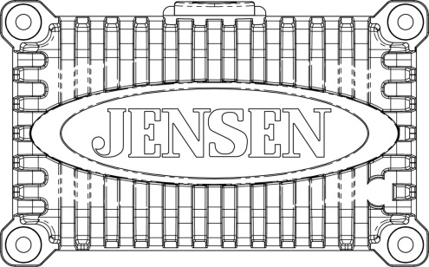  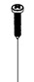  #8 Stainless  steel screws
  Black | Ground
  Yellow | +12V Battery
  Red | +12V Switched
  Gray | Right Front Speaker +
  Gray / Black | Right Front Speaker –
  White | Left Front Speaker +
  White / Black | Left Front Speaker –

Specifications  "WARNING: To Reduce The Risk Of Fire Or Electric Shock, Do Not Expose  This Apparatus To Rain Or Moisture"  The device shall not be exposed to dripping or splashing.  Do not place any sources of danger on the device (e.g. liquid filled objects,  lighted candles).  - Read these instructions.; 2) Keep these instructions. 3) Heed all warnings.  4) Follow all instructions; 5) Do not use this apparatus near water. 6) Clean only with dry cloth. 7) Do not block any ventilation openings. Install in accordance with the manufacturer’s instructions. 8) Do not install near any heat sources such as radiators, heat registers, stoves, or other apparatus (including amplifiers) that produce heat.  9) Do not defeat the safety purpose of the polarized or grounding-type plug. A polarized plug has two blades with one wider than the other. A grounding type plug has two blades and a third grounding prong. The wide blade or the third prong are provided for your safety. If the provided plug does not fit into your outlet, consult an electrician for replacement of the obsolete outlet.  10) Protect the power cord from being walked on or pinched particularly at plugs, convenience receptacles, and the point where they exit from the apparatus.  11) Only use attachments/accessories specified by the manufacturer.  12) Use only with the cart, stand, tripod, bracket, or table specified by the manufacturer, or sold with the apparatus. When a cart is used, use caution when moving the cart/apparatus combination to avoid injury from tip-over.  13) Unplug this apparatus during lightning storms or when unused for long periods of time.  14) Refer all servicing to qualified service personnel. Servicing is required when the apparatus has been damaged in any way, such as power-supply cord or plug is damaged, liquid has been spilled or objects have fallen into the apparatus, the apparatus has been exposed to rain or moisture, does not operate normally, or has been dropped. | Bluetooth Operation  Press the switch to power on JAHD240BT, press again to power off.  The JAHD240BT will automatically try to connect to the last paired Bluetooth device.  - When connected, the blue LED light will remain steady  - When not connected the blue LED light will flash slowly, see next section to connect a device  Pairing a Bluetooth Device  Press and Hold the switch for about 4 seconds to place the JAHD240BT in pairing mode. The JAHD240BT will remain in pairing mode for two minutes, and the blue LED will flash quickly. With a Bluetooth enabled mobile device search for, and connect to the amplifier identifying as “JAHD240BT” to complete the pairing.  After connecting successfully, you are able to listen to audio from your Bluetooth enabled device.    Adjust Bluetooth enabled device volume to lowest level before connecting to prevent possible speaker or hearing damage.  Bluetooth Audio Playback  All playback and volume options are controlled by the Bluetooth enabled device.  Bluetooth Range  Bluetooth is a short-range wireless radio protocol and operates at 2.4 GHz with an effective range of approximately 10 meters (30 feet).  If a Bluetooth connected device goes out of range for more than two minutes the JAHD240BT will disconnect and the blue LED will flash slowly. User intervention on the Bluetooth enabled device may be required to reconnect.  For copy of the owner’s manual visit www.ASAElectronics.com  • Connect the equipment into an outlet on a circuit different from that to which the receiver is connected.  • Consult the dealer or an experienced radio/TV technician for help.  Caution: Any changes or modiﬁcations to this device not explicitly approved by manufacturer could void your authority to operate this equipment.  This device complies with part 15 of the FCC Rules. Operation is subject to the following two conditions: (1) This device may not cause harmful interference, and (2) this device must accept any interference received, including interference that may cause undesired operation.  This equipment has been tested and found to comply with the limits for a Class B digital device, pursuant to part 15 of the FCC Rules. These limits are designed to provide reasonable protection against harmful interference in a residential installation. This equipment generates, uses and can radiate radio frequency energy and, if not installed and used in accordance with the instructions, may cause harmful interference to radio communications. However, there is no guarantee that interference will not occur in a particular installation. If this equipment does cause harmful interference to radio or television reception, which can be determined by turning the equipment off and on, the user is encouraged to try to correct the interference by one or more of the following measures:  • Reorient or relocate the receiving antenna.• Reorient or relocate the receiving antenna.  • Increase the separation between the equipment and receiver.
  Power System | 12V DC
  Operating Voltage Range | 10V to 16V
  Current Draw @ 12V | 1 mA (Standby)
  Current Draw @ 12V | 2.5 A (Nominal)
  Current Draw @ 12V | 5.0 A (Maximum)
  Operating Temperature Range | -30° C to 45° C
  Storage Temperature Range | -40° C to 85° C
  Maximum Relative Humidity | 100%
  Product Weight (unpackaged) | 1.0 lbs.
  Output Power RMS | 2 x 20 Watts
  Output Power Maximum | 2 x 40 Watts
  Total Harmonic Distortion | 0.5%




